Assignment 6: Auto-Tagging EC2 Instances on Launch Using AWS Lambda and Boto3

Objective: Learn to automate the tagging of EC2 instances as soon as they are launched, ensuring better resource tracking and management.

Task: Automatically tag any newly launched EC2 instance with the current date and a custom tag.

Instructions:

EC2 Setup:

Ensure you have the capability to launch EC2 instances.

Lambda IAM Role:

In the IAM dashboard, create a new role for Lambda.

Attach the AmazonEC2FullAccess policy to this role.

Lambda Function:

Navigate to the Lambda dashboard and create a new function.

Choose Python 3.x as the runtime.

Assign the IAM role created in the previous step.

Write the Boto3 Python script to:

Initialize a boto3 EC2 client.

Retrieve the instance ID from the event.

Tag the new instance with the current date and another tag of your choice.

Print a confirmation message for logging purposes  
  
Answer

**EC2 Setup:**

Make sure you have the to launch EC2. You can launch an EC2 instance from EC2 dashboard in the AWS Management Console.

. **Lambda IAM Role:**

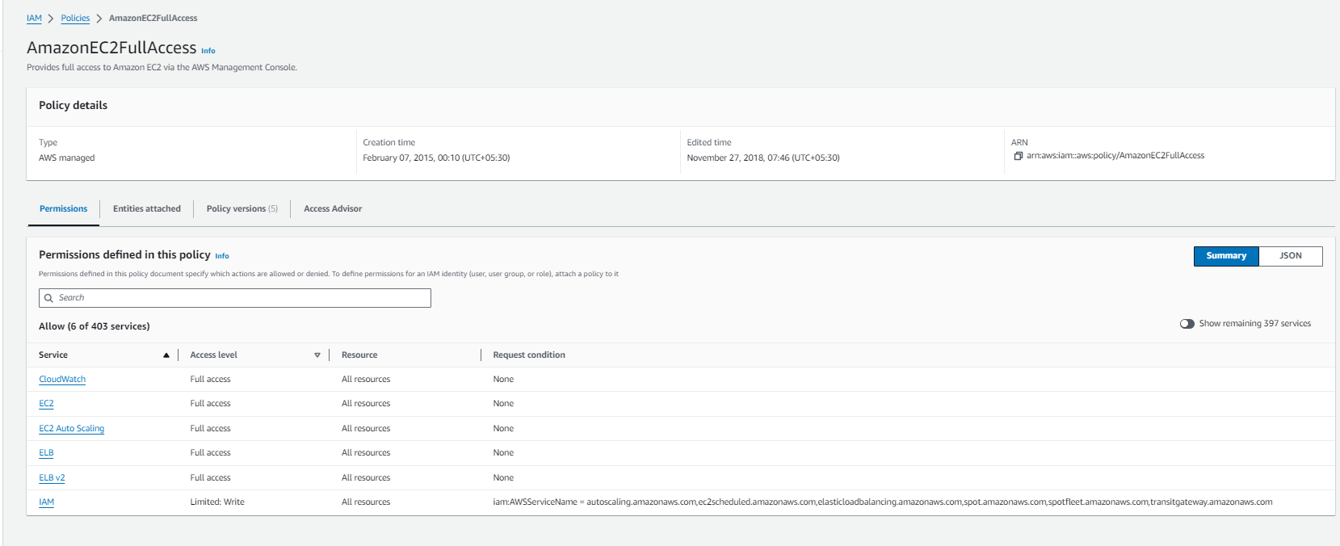

In the IAM dashboard, create a role for Lambda following these steps:

a. Click on "Roles" in the left-hand menu and then click the "Create role" button.

b. Choose "Lambda" as the service that will use this role and click "Next: Permissions".

c. Attach the AmazonEC2FullAccess policy to this role by searching for it in the policy library and selecting it.

d. Click "Next: Tags", add any tags if you like, and then click "Next: Review".

e. Give the role a name and click "Create role".

**Lambda Function:**  
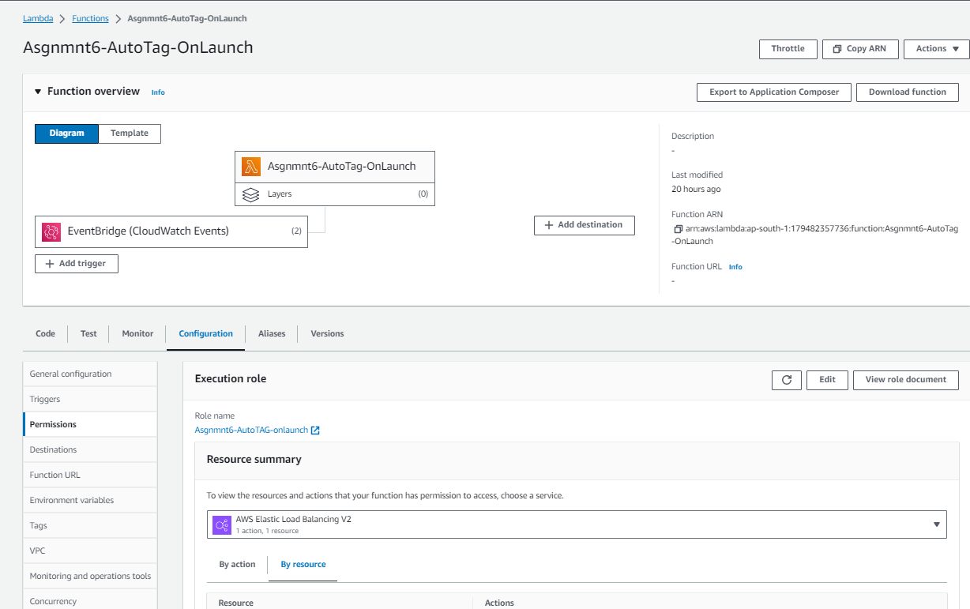

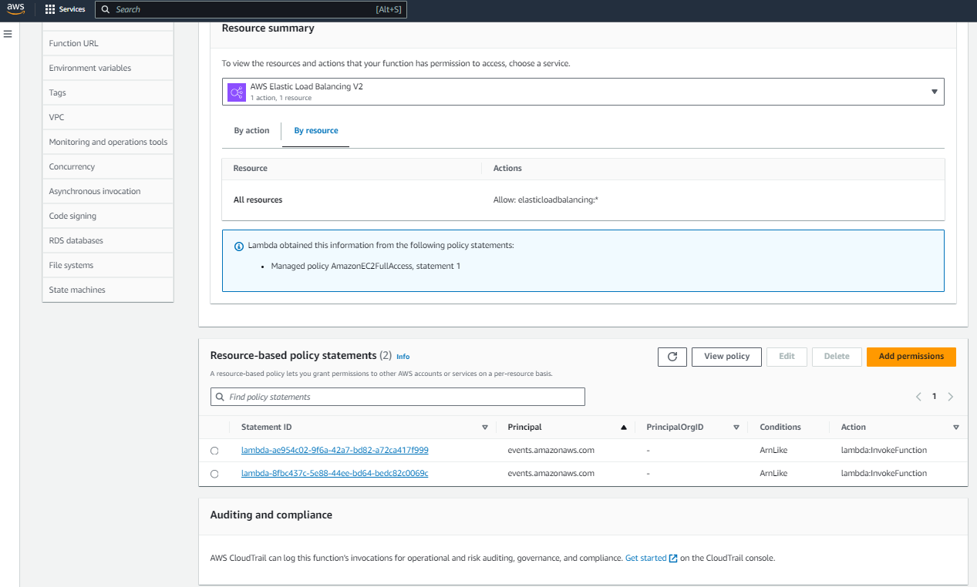  
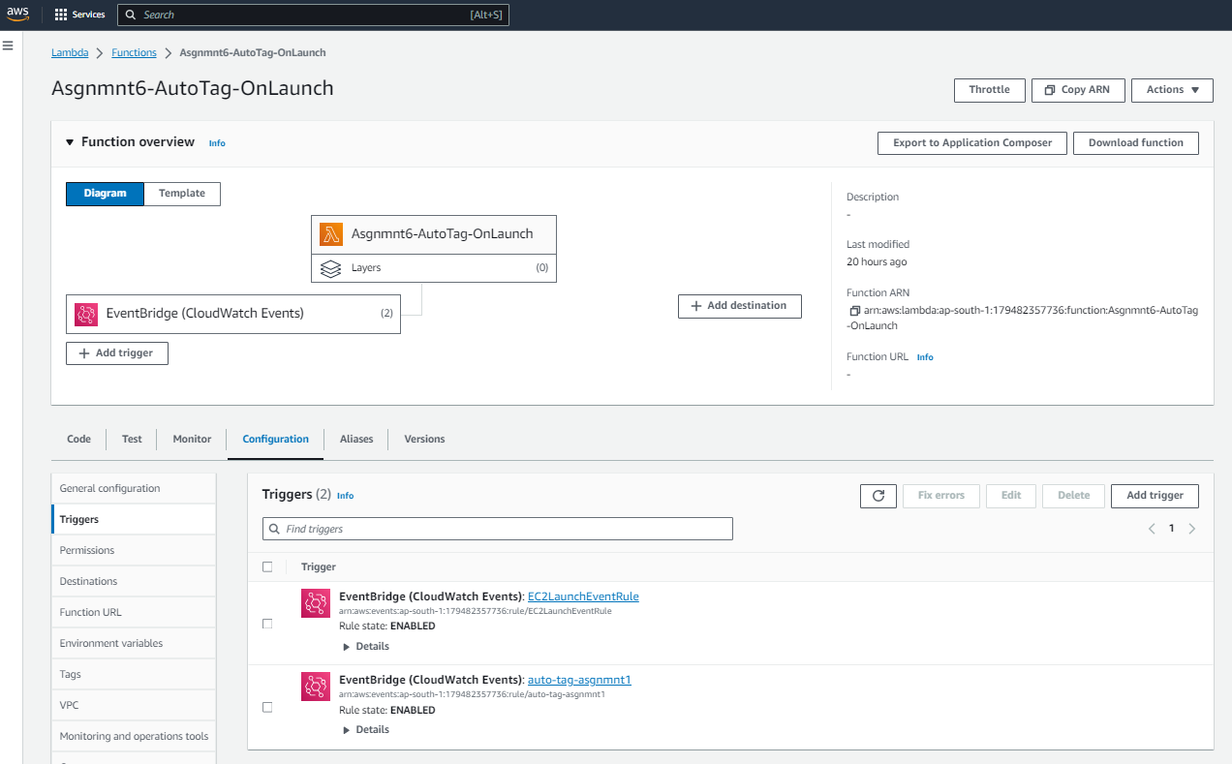  
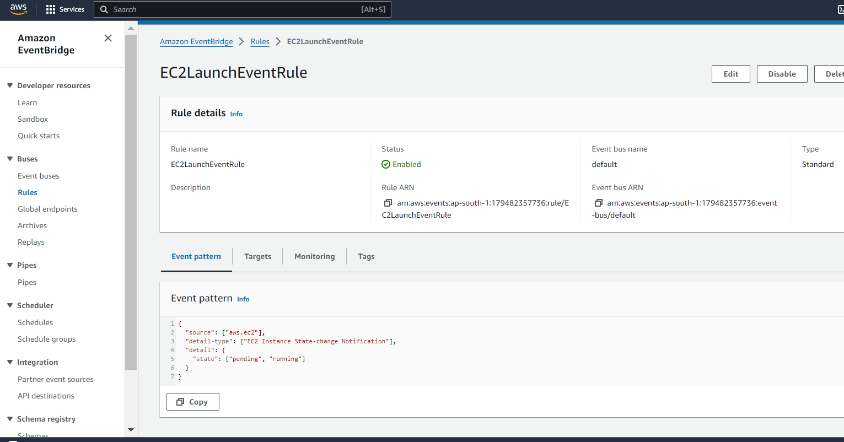

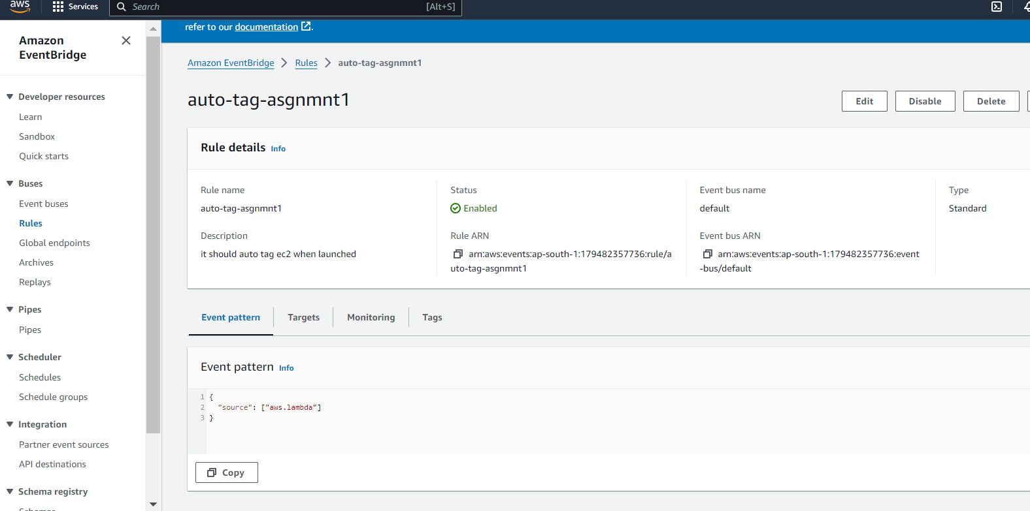

Navigate to the Lambda dashboard and create a new function by following these steps:

a. Click on the "Create function" button.

b. Choose "Author from scratch" and give your function a name (e.g., "autoTagEC2").

c. Choose Python 3.x as the runtime.

d. Under "Permissions", choose "Use an existing role" and select the IAM role you created in the previous step.

e. Write the **Boto3 Python script** to tag the new EC2 instance with the current date and another tag of your choice. Here's an example script:  
  
import boto3

import datetime

def lambda_handler(event, context):

try:

# Check if the event has a 'detail' field

if 'detail' in event and 'instance-id' in event['detail']:

# Initialize EC2 client

ec2_client = boto3.client('ec2')

# Retrieve the instance ID from the event

instance_id = event['detail']['instance-id']

# Define tags

tags = [

{'Key': 'BusinessOwner', 'Value': 'Subhra'},

{'Key': 'production', 'Value': 'Lambda Boto3'},

{'Key': 'LaunchDate', 'Value': datetime.datetime.utcnow().isoformat()}

# You can add more custom tags as needed

]

# Tag the new instance

ec2_client.create_tags(Resources=[instance_id], Tags=tags)

# Print a confirmation message for logging purposes

print(f"Instance {instance_id} tagged successfully.")

else:

print("Event does not contain necessary details for EC2 instance tagging.")

except Exception as e:

print(f"Error: {e}")

return {

'statusCode': 200,

'body': 'Instance tagged successfully.'

}

f. Save the function and test it by creating a new EC2 instance. You should see the confirmation message in the CloudWatch logs.

.

f. **Test the setup by launching a new EC2 instance.**

That's it! You have now set up auto-tagging of EC2 instances on launch using AWS Lambda and Boto3.  
  
